|  |
| --- |
| Circle Language Spec: Events |

## System Event Parameters

System events have parameters. First of all they have the This parameter, which identifies which object something’s happening to.

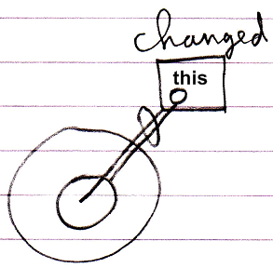

This can be an Object, but also for instance a Related Item.

|  |  |
| --- | --- |
|  |  |
|  |  |
| *The* This *parameter is a* Related Item | *The* This *parameter is an* Object |

Second of all for systems events that announce something is about to happen, usually have a Value parameter which indicates which value is about to be assigned and also a Cancel Boolean parameter to be able to assign the value True to, to cancel the event.

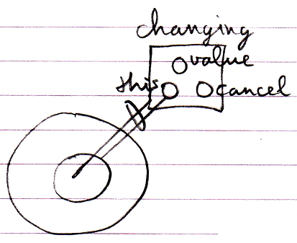

The List and Existence aspects have additional event parameters.

The Creating event have a Class and Interface parameter, which indicate which class or interface the new object will have.

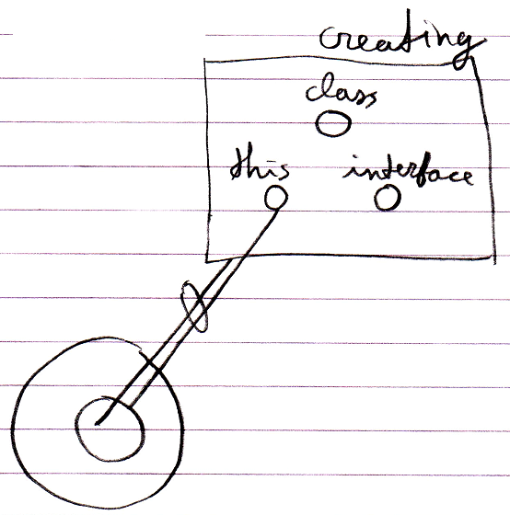

The Adding event has an Item parameter (an Object).

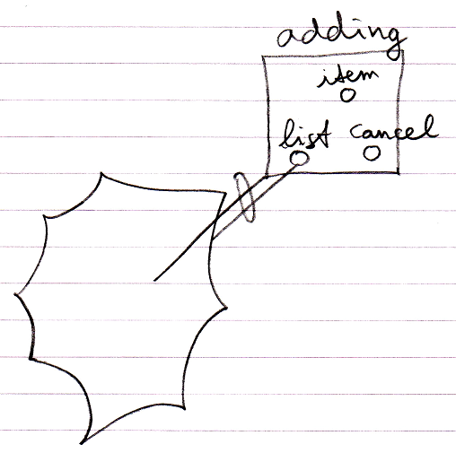

And the Added event has a List Item parameter (a Related List Item)

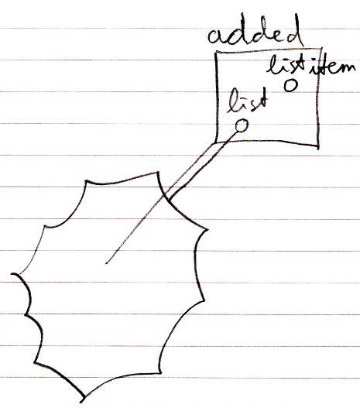

The Clone aspect’s events also have a Depth parameter.

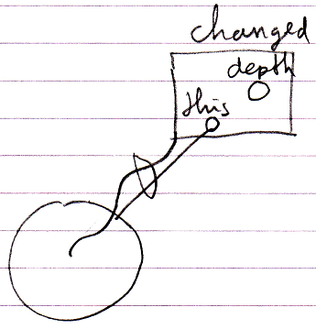

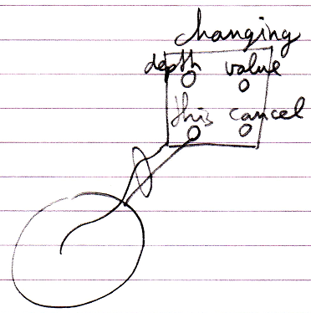

Possibly a Changed event will also contain the Previous Value parameter.

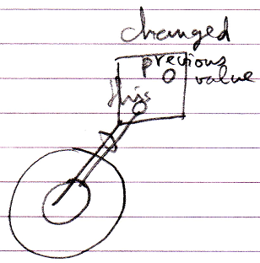

In the earlier introduced connector notation, parameters are not shown. But the parameters *are* shown in the event *implementations*.